Technical Specifications Document

Gen AI – Content Ingestion

TS Version 1.0

Project: | Gen AI – Content Ingestion
Doc. Name: | GenAI Content Ingestion v1.0.doc
Author: | Kriti Agarwal
Version: | V 1.0
Last Updated: | 22 Nov 2025

Issue / Amendment Record

Date | Version | Revision Description | Author

Role | Name | Position | Scope
Approver
Reviewer | Karthik | Director, Aspire Analytics

Table of Contents
1 Introduction 4
2 Technical Description/ Objective 4
3 Data flow 4
4 Reports 6
5 Technical Design – Peer Analysis App 7
• Background and Business Objective 7
• SOLUTION ACHITECTURE 7
• Python Application (Backend) 8
5.2.1 server.py (Main Flask Application) 8
5.2.2 embedding_storer.py (Embedding Processor) 9
5.2.3 api_client.py (Embedding Files API Client) 10
5.2.4 query_processor.py (Query Processor) 11
• Project Modules 13
5.2.5 Document Ingestion (PDF, Excel, Images) 13
5.2.6 Embedding Generation & Vector Storage (SAP AI Core + SAP HANA) 14
5.2.7 LLM-Powered Analysis (CODA Analysis via Claude 3.5 Sonnet or SAP GenAI Hub) 14
5.2.8 Full SAP BTP Authentication (XSUAA, Destination, VCAP Bindings) 15
5.2.9 Deployment Ready for SAP BTP Cloud Foundry (via mta.yaml) 15
5.2.10 Full Technology Stack Summary 16
5.2.11 Project Flow 17
5.2.12 Execution Flow 17
• SAP DATASPHERE 18
5.2.13 Spaces 18
5.2.14 Staging Layer (Inbound Layer) 19
5.2.15 Harmonisation Layer (Green Ledger (PaPM and PMI)Space) 21
5.2.16 Propagation Layer (ESG Unified Schema space) 23
5.2.17 Reporting Layer 24
• Design Consideration 27
5.2.18 Row level security 27
5.2.19 Authorisation scenarios 28
• Naming Standards - TBC 28
• Administration 29
5.2.20 SAP Datasphere Roles 30
5.2.21 Monitoring 30
• TECHNICAL SPECIFICATION – TASK CHAINS 31
• Task Definition 31
6 PLATFORM & INFRASTRUCTURE 32
• SAP ANALYTICS CLOUD CONNECTIVITY 32
• FOLDER STRUCTURE 32
• USER SECURITY 32
• Roles 32
• Teams 32
• Users 32
• SAP DATASPHERE CONNECTIONS 32
• SAP HANA Cloud Live connection 32
• SINGLE SIGN ON 32
• PERFORMANCE 32
• Scalability and Projected Growth 32
• Capacity / Load / Throughput 33
• CLIENT 33
• Network 33
• Archiving & Retrieval 33
• Disaster Recovery 33
• Monitoring and Logging 33
7 APPENDIX C – DEPLOYMENT STEPS 34

- Introduction
The Peer Analysis and Treasury AI applications require similar functionality to ingest and approve documents, either documents such as quarterly results or Treasury documents to use for AI (Content) or for peer bank terminology synonyms (Standard Account Line Mappings) or to explain the usage of specified fields (Data Dictionary). Both applications have built similar functionality and it has been decided to fuse these requirements into a single application that can be used for Peer Analysis, Treasury AI and any other to-be-built AI applications. This document specifies the solution requirements for the application.

- Technical Description/ Objective
The Objective of this document is to compile all the development objects created in SAP BAS (Business application studio) – Python App, CAP App and Fiori/UI5 app with database in classical HANA DB and HANA HDI container and accessing AI models using SAP AI Core platform. This document will be used as input for components of the development and testing.
- Data flow
Content Ingestion – Data Flow:
The data flow for the Gen AI Content Ingestion App begins with the ingestion of earnings documents from peer banks. This streamlined data flow ensures efficient ingestion, verification, storage, and transformation of financial documents, facilitating robust and agile peer analysis. This process involves several key steps:
- Document Submission: The Maker uploads and submits various earnings documents, including press releases, investor presentations, financial supplementary data, and earnings call transcripts, into the application for review.
- Document Verification: The Checker reviews these documents to ensure accuracy and completeness. Upon verification, the documents are approved and stored in the HANA database as Binary Large Objects (BLOBs).
- Data Transformation: A Python application processes the stored documents, converting them into vector embeddings. These embeddings are then stored in a Vector Database.
- Enhanced Querying and Analysis: The transformation into vector embeddings enables Retrieval-Augmented Generation (RAG) using foundational models, significantly enhancing the system's capability for advanced semantic querying and analysis.

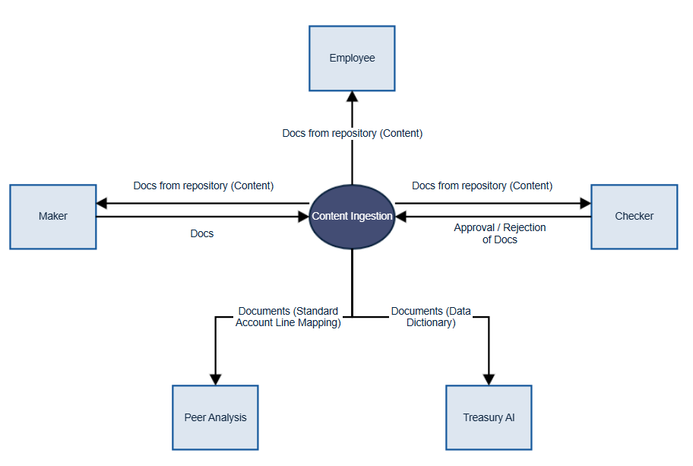
- Users with role of Maker upload files into the system
- Users with role of Checker assess (approve or reject) the storage and processing of the files
- Consumption
  - Users with role of Employee (all users have this role) are able to download files (once they’ve been approved)
  - Users with role of Maker or Checker can download files irrespective of whether approved
  - The Peer Analysis app consumes Standard Account Line Mapping files
  - The Treasury AI app consumes Data Dictionary files
- Technical Design – Content Ingestion App

SOLUTION ACHITECTURE
The design of this solution is to compile all the development objects created in SAP BAS (Business application studio) – Python App, CAP App and Fiori/UI5 app with database in classical HANA DB and HANA HDI container and accessing AI models using SAP AI Core platform. Refer following diagram for more details.
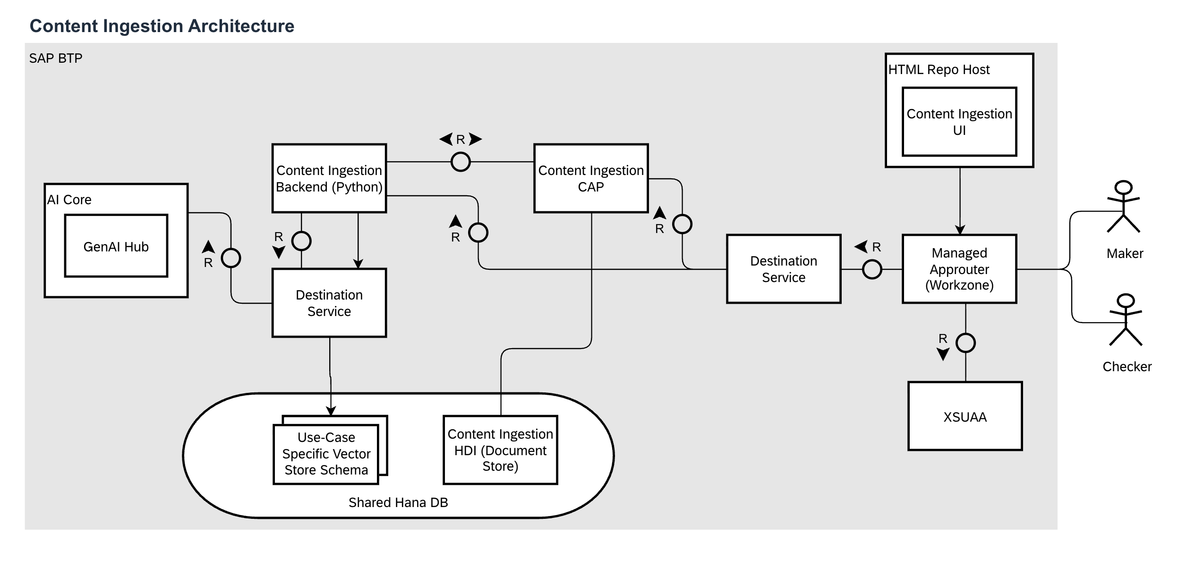

CAP Full stack application.

The front end UI/ Fiori based module acts as entry point to the application. The UI Application is hosted in SAP Business workzone and controlled through standard workzone role / group based access. The fullstack application is split into the following modules

- App
- DB
- Srv

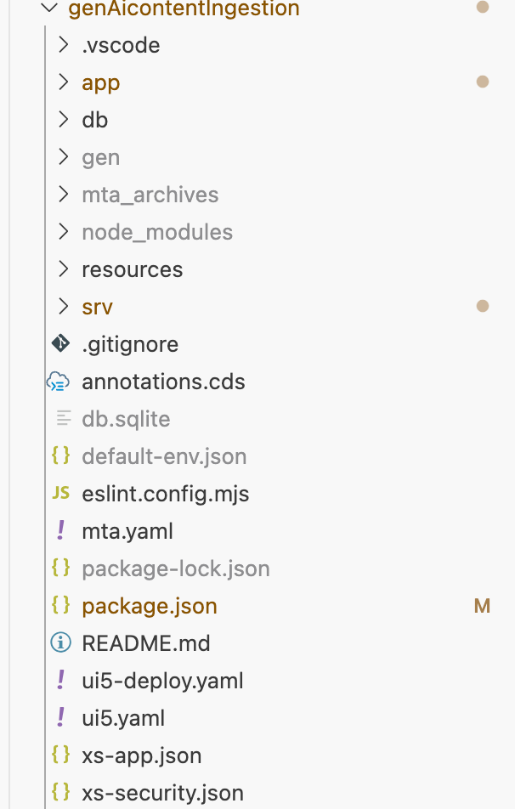

- App Module
App module serves all the UI applications that are integrated with the workzone. Following are the list of apps developed and deployed
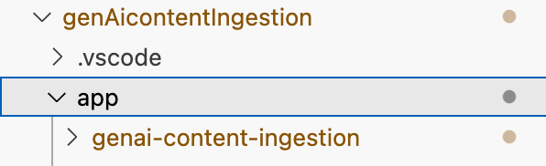

Genai-Content Ingestion app serves as the entry point with a single interface app.

- Data Base Modelling and View Projection
The Application has the only the Content Ingestion list report view that is driven by annotation based odata generation via CAP Model
The following table depicts the relation ship between the view and the db model

View Name | Entity | App Page | Entity Content
Content Ingstion | Content | 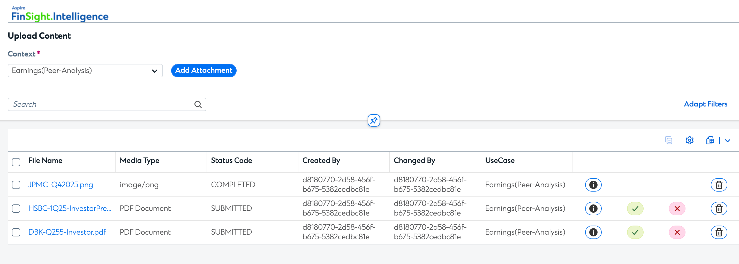 | entity Content : managed {  @UI.AdaptationHidden: true  key ID : String;  @UI.AdaptationHidden: true  status_reason: String;  @Common.Label : 'File Name'  fileName : String;  mediaType : String;  @UI.AdaptationHidden: true  tagType : String;  status : String;  @UI.HiddenFilter: true  embeddingStatus : String;  @UI.AdaptationHidden: true  url : String;  @Core.MediaType : mediaType  content : LargeBinary;  @UI.AdaptationHidden: true  metaData : LargeString;  @UI.HiddenFilter: true  isChecker : Boolean;  UseCase : String;  @UI.HiddenFilter: true  team : String;  @UI.HiddenFilter: true  fileType : String;  }
Standard Reports | EarningFiles | 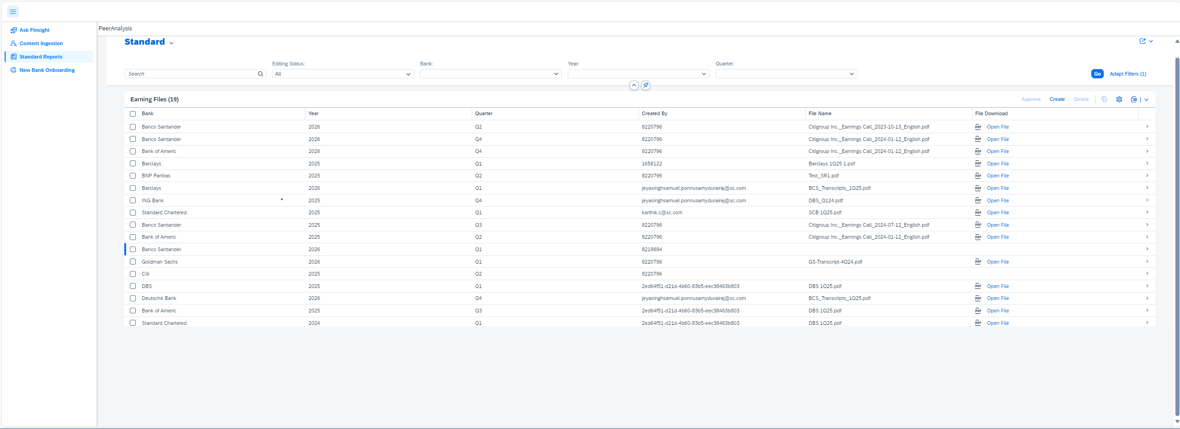 | entity EarningFiles : cuid, managed {  bank : Association to Banks;  year : Association to Years default '2025';  quarter : Association to Quarters;  @Core.MediaType : mediaType  content : LargeString;  @Core.IsMediaType: true @UI.Hidden  mediaType : String;  fileName : String;  @UI.Hidden  url : String;  @Consumption.filterable : true  @Common.ValueList: {  CollectionPath: 'EarningsFileStatusValues',  Parameters: [  {  $Type: 'Common.ValueListParameterInOut',  LocalDataProperty: 'status',  ValueListProperty: 'code'  }  ]  }  @Common.ValueListWithFixedValues: true  status : String default 'Submitted';  }
New Banks Onboarding | Banks | 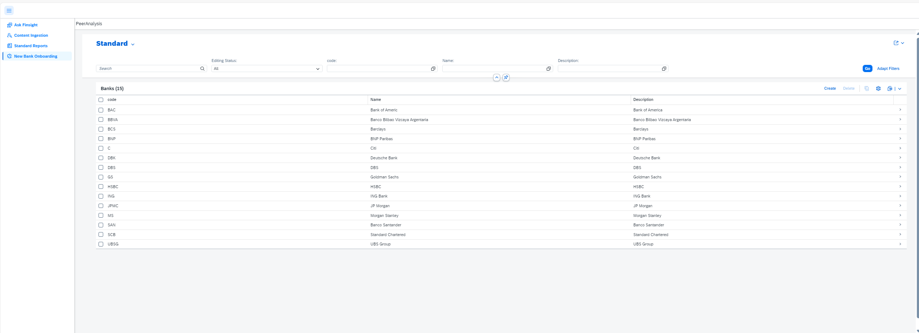 | entity Banks : CodeList {  key code : String(40);  }

- Service (Srv) Modules

Entity Name | Service Defenition | Service Implementation
EarningFiles | Service.cds | Service.js
EmbeddingFiles | Service.cds | Service.js
Bank | Bank.cds | Bank.js

- Application Security

- Authentication for the app is handled at the “service.cds” level using annotation.
- Authorization is handled through XS-Security.json file

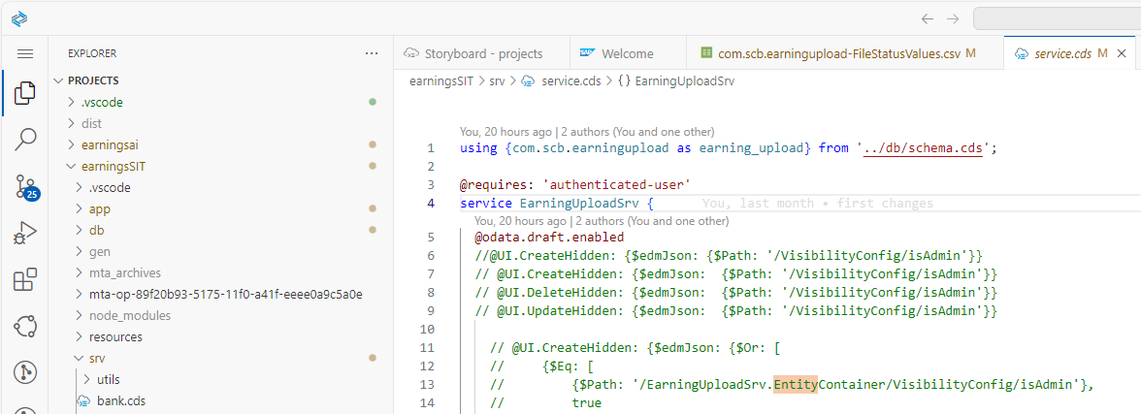

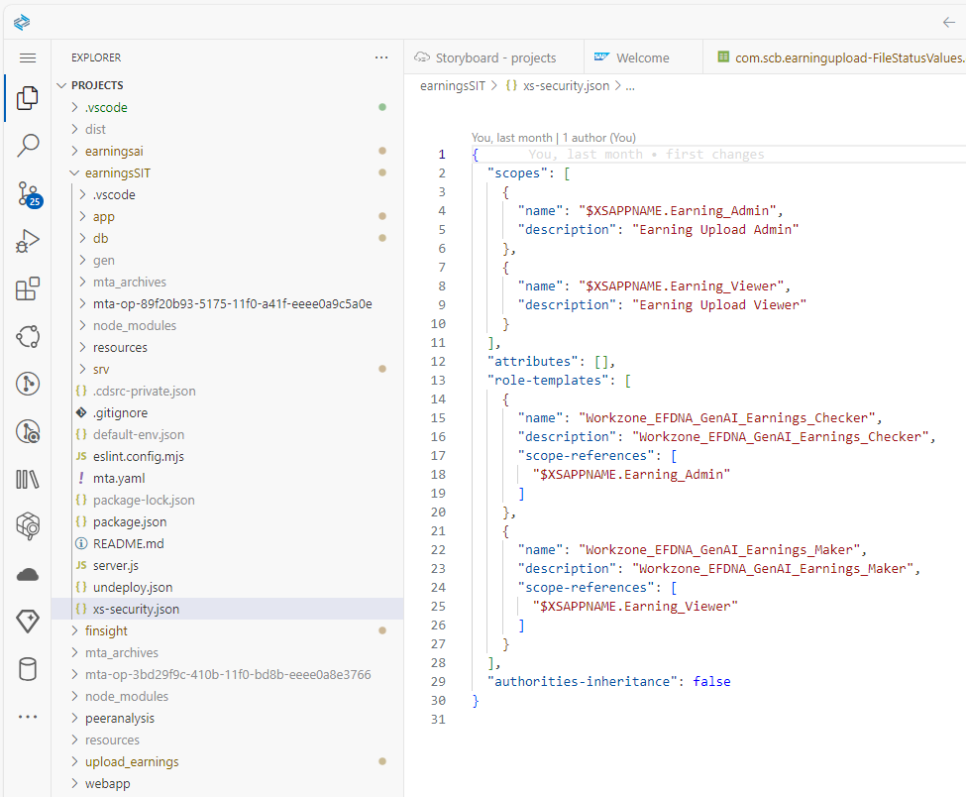

` | Roles
Checker | Workzone_EFDNA_GenAI_Earnings_Checker
Maker | Workzone_EFDNA_GenAI_Earnings_Maker
Viwer | Anyone Authenticated via IAS and has access to workzone can view the application
Support | Workzone_EFDNA_GenAI_Earnings_Maker  Workzone_EFDNA_GenAI_Earnings_Checker

Python Application (Backend)
This backend system provides an AI-powered document processing and analytics platform integrated with SAP BTP. It supports:
- File ingestion via API.
- File metadata storage in HANA DB
- Embedding generation using SAP AI Core
- Vector storage using LangChain and HanaDB integration.
- Query processing using multi-modal (text, excel, image) retrieval.
- Analysis using LLM orchestrations.
The system is composed of four core modules:

server.py (Main Flask Application)

5.2.1.1 Responsibilities:
  - Flask web server handling API routes for file upload, health check, chat interface, and embedding generation.
  - Manage OAuth2-based authentication using SAP XSUAA.
  - Retrieve SAP BTP Destination Service credentials to securely connect to SAP HANA Cloud and AI Core services.
  - Initialize HANA DB connections for metadata storage.
  - Manage file uploads to local directories, validate file formats, and store associated metadata into HANA.
  - Trigger embedding generation via dedicated API.
  - Serve as an orchestration entry-point for downstream AI-powered embedding pipelines.

5.2.1.2 Components:
  - Authentication: require_auth decorator for protecting endpoints.
  - Destination Service Integration: Calls to fetch service credentials for HANA and AI Core.
  - Metadata Storage: Writes file metadata into HANA DB FILE_METADATA table.
  - Embedding Generation Orchestration: Coordinates file download, processing, and embedding storage workflows.
  - Logging: Comprehensive rotating file handler for all server-side logs.

5.2.1.3 Key Endpoints:
  - /api/health_check: Server health status.
  - /api/status: Detailed system status including credential and store readiness.
  - /api/chat: Query interface leveraging vector search and LLM orchestration.
  - /api/upload: File upload interface storing file content locally and metadata in HANA.
  - /api/generate-embeddings: Embedding generation trigger that invokes downstream processing logic.

5.2.1.4 Code Flow:

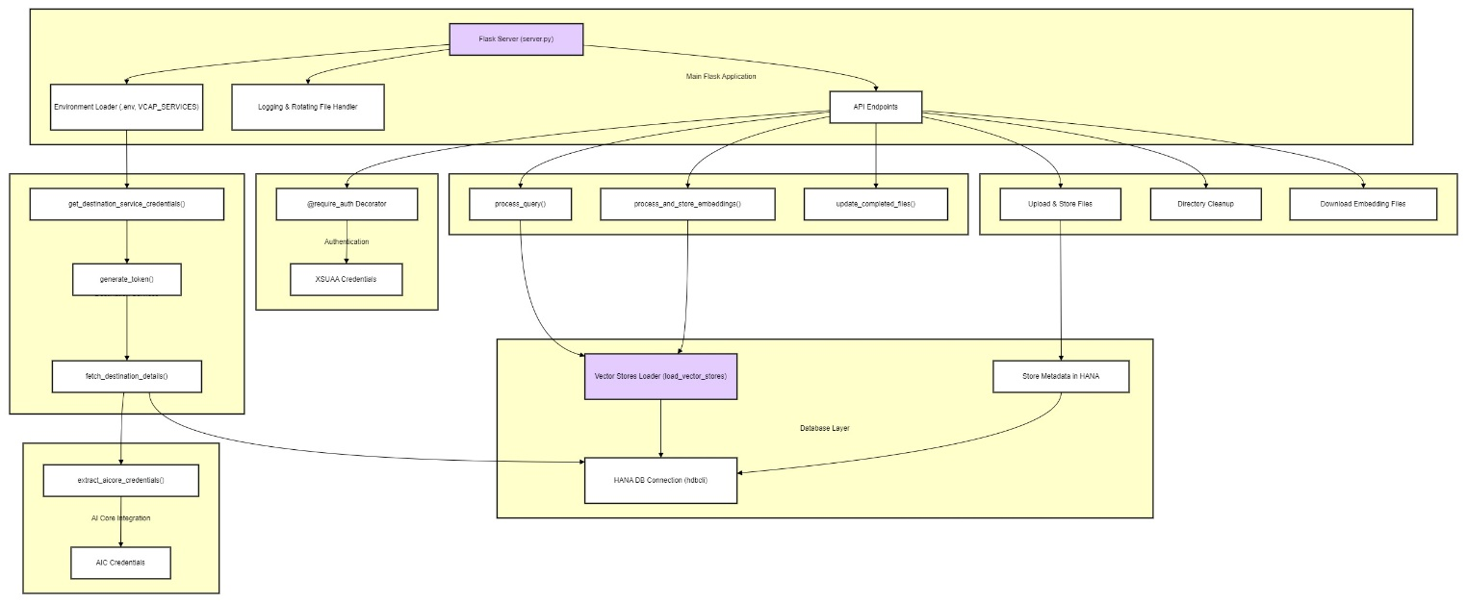

embedding_storer.py (Embedding Processor)

5.2.2.1 Responsibilities:
  - Perform embedding generation by processing new or updated files.
  - Retrieve and validate credentials for SAP AI Core via Destination Service.
  - Detect new files using MD5 hash comparisons with historical hashes stored in HANA.
  - Categorize files into transcript PDFs, non-transcript PDFs, and Excel documents.
  - Initialize SAP GenAIHub Proxy Client to connect to SAP AI Core models.
  - Use LangChain HanaDB VectorStore integration for storage of generated embeddings.
  - Deduplicate vector records by truncating and reinserting unique rows based on source_file, page, and content_hash metadata.

5.2.2.2 Submodules:
  - Hash Computation: Compute MD5 content hashes for detecting file changes.
  - File Categorization: Distinguish between PDF transcripts, PDF non-transcripts, and Excel files.
  - Embedding Generation: Process PDF and Excel files into embeddings via model calls.
  - Metadata Validation: Sanitize metadata fields before database insertion.
  - Vector Store Management: Direct interaction with LangChain HanaDB Vector Stores for insertion and validation.
  - Duplicate Removal: Clean duplicate vector records post insertion.

5.2.2.3 Workflow:
  - Load directory files.
  - Compare file hashes against HANA DB records.
  - Process PDFs and Excels requiring embedding generation.
  - Initialize GenAIHub Proxy Client and load AI Core embedding models.
  - Insert embeddings into respective HanaDB tables.
  - Deduplicate tables post processing.

5.2.2.4 Code Flow:

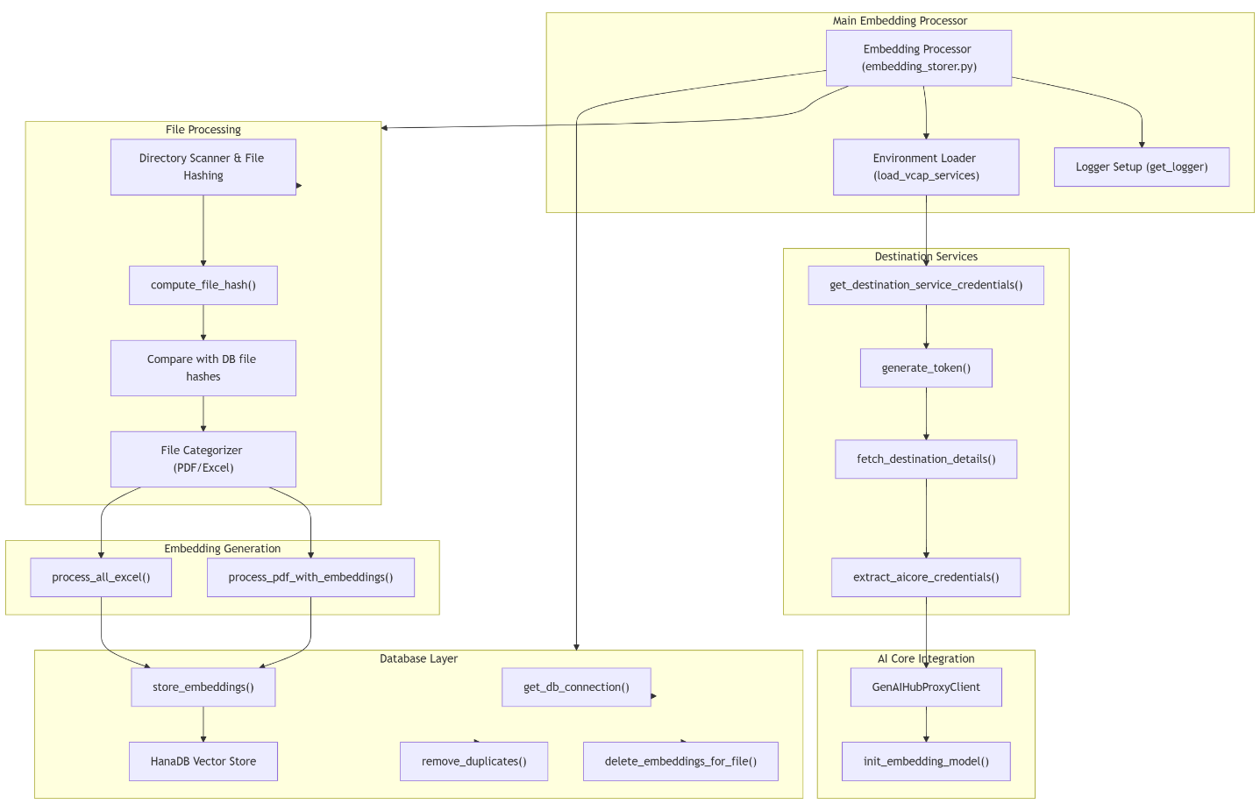

api_client.py (Embedding Files API Client)

5.2.3.1 Responsibilities:
  - Communicate with external CAP-based EmbeddingFiles OData API.
  - Retrieve OAuth token for secure CAP API access.
  - Download approved files submitted to CAP application layer.
  - Update file statuses to ‘Completed’ or ‘Failed’ based on downstream processing.
  - Act as data ingestion bridge between file submission UI and backend embedding pipelines.

5.2.3.2 Components:
  - Destination Service Credential Retrieval: Load CAP credentials via Destination Service.
  - CAP OAuth Token Management: Request client credentials token from CAP authentication server.
  - File Listing: Retrieve submitted files from CAP EmbeddingFiles API using status filters.
  - File Downloading: Download binary content to local directories for downstream processing.
  - File Status Update: Update each file’s processing status via PATCH requests.

5.2.3.3 Key Functions:
  - get_auth_token(): Retrieve OAuth token from CAP.
  - get_file_mappings(): Map file names to file IDs from CAP EmbeddingFiles API.
  - download_embedding_files(): Download approved files to local disk.
  - update_file_status(): Update individual file status.
  - update_completed_files(): Bulk status update for all successfully processed files.

Code Flow:
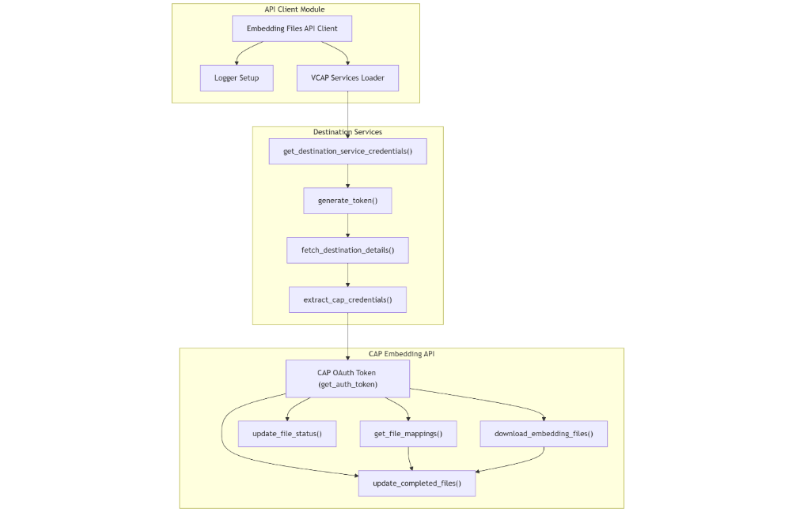

query_processor.py (Query Processor)

5.2.4.1 Responsibilities:
  - Full query orchestration engine supporting multi-modal data sources (transcripts, non-transcripts, Excel, images).
  - Parse user queries into specialized analysis types.
  - Fetch relevant vector embeddings from multiple LangChain HanaDB stores.
  - Execute LLM orchestration for multi-step reasoning using AI Hub orchestration framework.
  - Handle special processing for image-based stock queries via dedicated image analysis pipeline.
  - Compose integrated prompts that consolidate multiple data sources and task outputs.
  - Format structured HTML outputs suitable for chat-based UI display.

5.2.4.2 Components:
  - Text Processor: Query parsing and document formatting logic.
  - CODA Analyzer: Generate specialized prompts that instruct LLMs how to integrate retrieved data.
  - LLM Client: Execute multi-step prompt orchestration for final response synthesis.
  - Vector Store Retrieval: Use LangChain retrievers with similarity score thresholds.
  - Image Processor: Analyze image data (such as stock charts) and extract insights.
  - Threaded Execution: Parallel execution of multiple sub-tasks using ThreadPoolExecutor.

5.2.4.3 Analysis Types Supported:
  - financial: Financial metric summaries
  - trend: Forward-looking business trends
  - general: Overall executive summaries
  - topics: Extract weighted key topics from transcripts.
  - quotes: Extract management quotes with speaker roles
  - callouts: Key driver identification
  - consensus: Market consensus summaries
  - stock: Stock price movements, volumes, and management commentary

5.2.4.4 Workflow:
  - Parse query into analysis types.
  - Retrieve transcript and non-transcript context from HanaDB vector stores.
  - Execute parallel analysis for different analysis types.
  - Generate prompt integrating multiple sub-analysis tasks.
  - Call LLM orchestration for final response generation.
  - Format final results into structured HTML for chat interface delivery.

5.2.4.5 Code Flow:

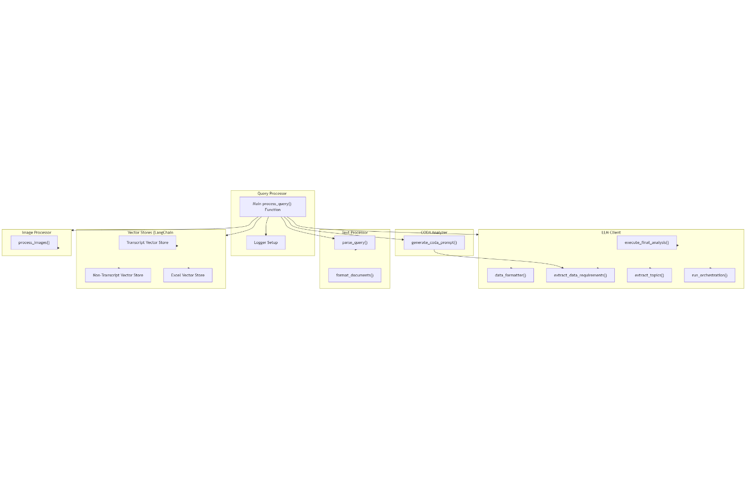

Project Modules

Document Ingestion (PDF, Excel, Images)
Purpose:
- Allow users to upload multiple file types containing financial data.
- Pre-process these files to extract structured and unstructured data for further AI analysis.
Components involved:
File Type | Processor | Description
PDF | pdf_processor.py | Extracts text content from PDF (financial reports, earnings statements, balance sheets, etc.).
Excel | excel_processor.py and excel_query_processor.py | Reads financial data from Excel sheets (structured data, tables).
Image | image_processor.py | Applies OCR (Optical Character Recognition) to convert images of tables, reports, scanned pages into text.
Outcome:
- Clean, text-based content ready for embedding generation.

Embedding Generation & Vector Storage (SAP AI Core + SAP HANA)
Purpose:
- Convert text data into high-dimensional embeddings (vector representation of semantic meaning).
- Store embeddings for similarity-based search (semantic search).
Components involved:
Stage | Component | Description
Embedding Generation | llm_client.py → api_client.py → SAP GenAI Hub (Text-embedding-3-large) | Calls an embedding model to generate numeric vector embeddings from extracted text chunks.
Storage | embedding_storer.py | Saves embeddings into SAP HANA as vector database (can be native HANA PAL TextEmbedding or external embeddings).
Database Connection | db_connection.py | Manages connectivity to SAP HANA database for storage and retrieval.
Outcome:
- All ingested documents are converted into searchable vector format for later retrieval.

LLM-Powered Analysis (CODA Analysis via Claude 3.5 Sonnet or SAP GenAI Hub)
Purpose:
- Once user submits a query, system finds related documents and generates a financial analysis report.
Components involved:
Stage | Component | Description
Query Processing | query_processor.py | Orchestrates Retrieval-Augmented Generation (RAG): 1) Retrieve relevant document chunks, 2) Formulate prompt.
Prompt Engineering | coda_analyzer.py, prompt_CODA.txt | Dynamically builds detailed financial analysis prompts (CODA = Company Data Analysis).
LLM Invocation | llm_client.py | Calls LLM endpoint (Claude 3.5 Sonnet, or SAP GenAI Hub models).
Post-Processing | data_formatter.py | Formats the LLM output into styled HTML executive summary report.
Outcome:
- A highly contextual, accurate, and explainable financial analysis report is generated for the end user.

Full SAP BTP Authentication (XSUAA, Destination, VCAP Bindings)
Purpose:
- Secure the entire application following enterprise-grade authentication, authorization, and service connectivity standards on SAP BTP.
Components involved:
Component | File | Description
XSUAA | xsuaa_srv.py,  xs-security.json | Handles OAuth2 authentication, user identity verification via SAP Identity Authentication Service (IAS).
VCAP Services | vcap_services.json | Contains SAP BTP service bindings for local development (HANA, Destination, AI Core etc.).
Destination Service | destination_srv.py | Securely connect to external services (SAP AI Core, SAP GenAI Hub etc.) using destinations and service keys.
Outcome:
- User authentication, service calls, and DB access are fully secured using SAP BTP native mechanisms.
- In the Destination Services: the Following Destinations are maintained and are read in server.py module to establish the connections.

EARNINGS_AIC:
- EARNINGS_AIC is the destination, that needs to be maintained for AI Core Credentials and the same will be used for initializing the AI Models in the server.py module.
- Text Embedding Model: Text-embedding-3-large
- Orchestration Model:
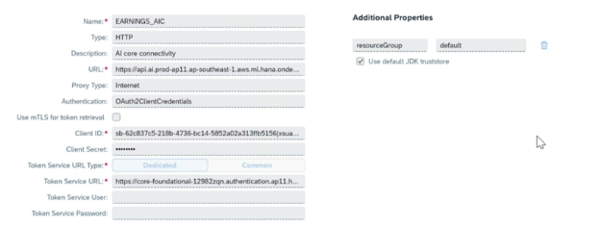
- EARNINGS_HDB:
- EARNINGS_HDB is the destination, that needs to be maintained for HANA DB Credentials and the same will be used for initializing for HANA Cloud DB Vector Store in the server.py module.
Note: Python Class “from langchain_community.vectorstores import HanaDB()”, it will create tables automatically, if it does not exists.
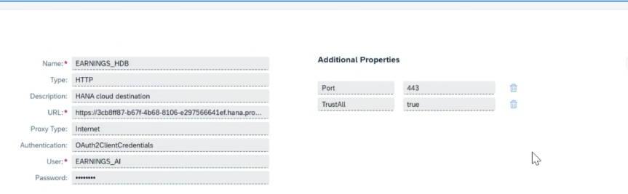

- EARNINGS_XSUAA / peeranalysis: (CAP XSUAA)

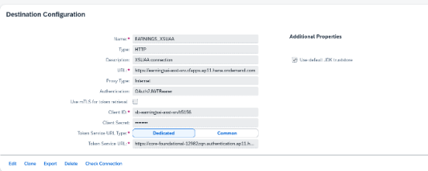

- EARNINGS_CORE (Python Destination):

Like the EARNINGS_XSUAA, the Destination Earnings_CORE Needs to be maintained that would establish the secured connection between Python Application and CAP Application.



: destination_srv.py

VCAP_SERVICES Loader:
- Function: load_vcap_services(local, vcap_services_path)
- Responsibility: Reads and validates the VCAP_SERVICES JSON, handling both local files and environment variables.

Destination Service Credential Extraction
- Function: get_destination_service_credentials(vcap_services)
- Responsibility: Parses the VCAP_SERVICES JSON to extract credentials for the SAP Destination service (OAuth URLs, client ID/secret, base URI).

OAuth Token Generation
- Function: generate_token(uri, client_id, client_secret)
- Responsibility: Requests an OAuth token from the destination service using client credentials.

Destination Details Fetching
- Function: fetch_destination_details(uri, name, token)
- Responsibility: Uses the OAuth token to fetch specific destination configuration details (e.g., HANA, AI Core, CAP) via REST API.

Credential Extraction for Downstream Services
- Functions:
  - extract_hana_credentials(config)
  - extract_aicore_credentials(config)
  - extract_cap_credentials(config)
- Responsibility: Extracts and structures the credentials/configuration for each downstream service from the destination configuration.

xsuaa_srv.py

XSUAA Credentials Extraction
- Function: get_xsuaa_credentials(vcap_services)
- Responsibility:
  - Parses the provided VCAP_SERVICES JSON.
  - Extracts XSUAA credentials (client ID, secret, URL, app name).
  - Returns credentials as a dictionary.

JWT Token Verification
- Function: verify_jwt_token(token, uaa_credentials, required_scope)
- Responsibility:
  - Decodes the JWT token (without signature verification for logging).
  - Uses SAP’s xssec library to create a security context and verify the token against XSUAA.
  - Checks if the token contains the required scope.
  - Raises HTTP 403 if verification fails or scope is missing.

Authentication Decorator
  - Function: require_auth(f)
  - Responsibility:
    - Flask decorator to enforce authentication on endpoints.
    - Extracts the Bearer token from the request header.
    - Retrieves XSUAA credentials from the Flask app context.
    - Calls verify_jwt_token to validate the token and scope.
    - Returns appropriate HTTP errors if authentication fails.
    - Calls the wrapped endpoint if authentication succeeds.

Deployment Ready for SAP BTP Cloud Foundry (via mta.yaml)
Purpose:
- Enable automated deployment of the entire application stack on SAP Business Technology Platform (BTP).
Components involved:
Artifact | File | Description
MTA Descriptor | mta.yaml | Multi-Target Application descriptor that defines app modules, resources, services, routes, and deployment configurations.
Buildpack | Procfile, runtime.txt | Used to deploy Python Flask app on SAP BTP Cloud Foundry environment with required runtime and gunicorn web server.
Resources | HANA Cloud, AI Core, XSUAA | All SAP BTP managed services are automatically bound during deployment via mta.yaml.
Outcome:
- Fully cloud-native, highly scalable, and production-ready deployment with SAP BTP services integrated.
- Below is the reference mta.yaml file for backend services that are being configured and binded.

### ===========================================================
### 📦 MODULE: Python Backend App (earningai-asst-srv)
### ===========================================================
modules:
- name: earningsai-asst-ST # [Important] Name of the Python backend module
type: python # [Important] Module type (python for Python apps)
path: scripts # [Important] Path to the source code directory
parameters:
instances: 1 # [Optional] Number of app instances
memory: 5G # [Important] Memory allocation per instance
disk-quota: 5G # [Important] Disk quota per instance
buildpack: python_buildpack # [Important] Specifies the Cloud Foundry buildpack
command: gunicorn server:app --bind 0.0.0.0:$PORT # [Important] Start command for the app
host: earningsai-asst-srv6 # [Important] Hostname for the app route
#domain: cfapps.ap11.hana.ondemand.com # [Optional] Custom domain (commented out)
properties:
FLASK_ENV: PRODUCTION # [Optional] Flask environment variable
FLASK_APP: server.py # [Optional] Flask app entry point

# 🔗 Service bindings ( Instances)
requires:
- name: xsuaa_earningsai # [Important] Binds XSUAA service instance
- name: dest_earningsai # [Important] Binds Destination service instance

build-parameters:
builder: custom # [Optional] Custom build process
build-result: . # [Optional] Build output directory
ignore: # [Optional] Files/folders to ignore during build
- __pycache__/
- node_modules/
- logs/
commands:
- pip install -r requirements.txt # [Important] Install Python dependencies

### ===========================================================
### 🔐 RESOURCE: XSUAA Authentication
### ===========================================================
resources:
- name: xsuaa_earningsai # [Important] Resource name for XSUAA
type: org.cloudfoundry.managed-service # [Important] Managed service type
parameters:
service: xsuaa # [Important] Service type (XSUAA)
service-plan: application # [Important] Service plan
path: xs-security.json # [Important] Path to XSUAA security descriptor
config:
xsappname: earningsai-asst-srv # [Important] XSUAA application name

### ===========================================================
### 🗃️ RESOURCE: SAP Destination Services
### ===========================================================
- name: dest_earningsai # [Important] Resource name for Destination service
type: org.cloudfoundry.managed-service
parameters:
service: destination # [Important] Service type (Destination)
service-plan: lite # [Important] Service plan (lite = free tier)

Full Technology Stack Summary

Layer | Technology
Frontend | UI5 Application
Backend API | Flask REST API
Document Processing | Python (PDF, Excel, Image processors)
Embedding Models | SAP GenAI Hub (Text-embedding-3-large)
Vector DB | SAP HANA Cloud (vector search)
Authentication | SAP XSUAA, IAS
Deployment Platform | SAP BTP Cloud Foundry
Integration | SAP Destinations, VCAP Services

Project Flow

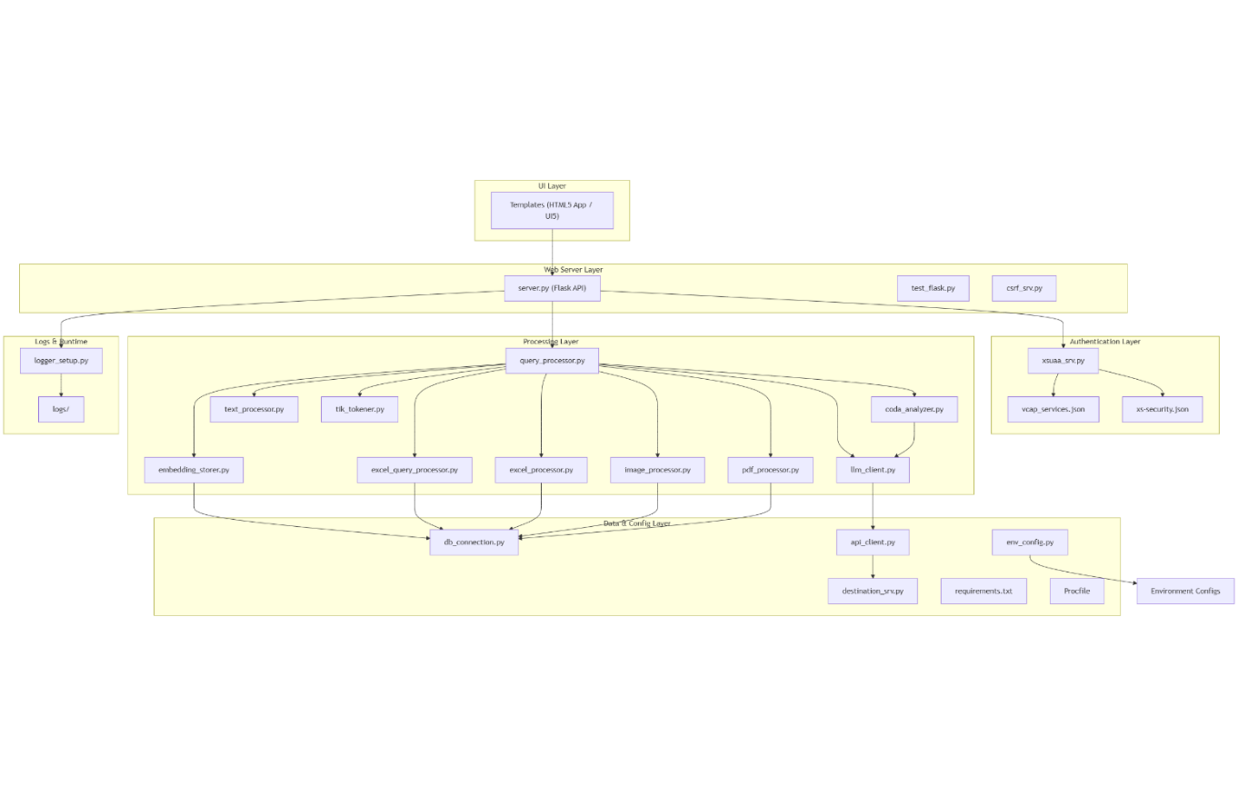

Execution Flow

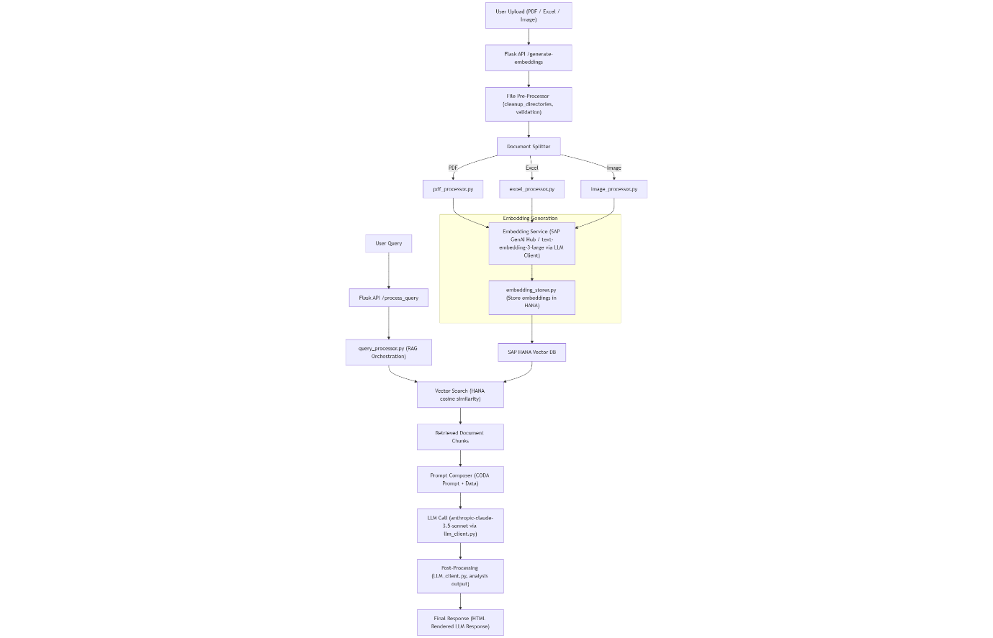

Reports are delivered as SAC stories and aims to replicate the existing visualisations to minimise change impact.
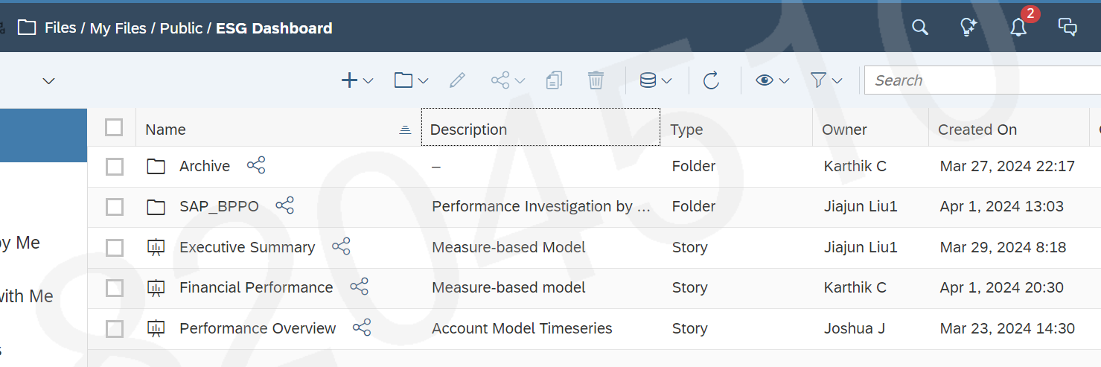
Users can click on the respective story, and it will open the reports. Reports can be exported to excel/csv.

SAP DATASPHERE

Spaces
Spaces are virtual work environments within the SAP Datasphere environment that allocate disk and in-memory storage and workload priority. Users are assigned access to spaces. Objects within a space can be shared for access by another space.
While all objects can be built in one space, multiple spaces allow separation for security, performance, and storage management.
The following spaces are created for ESG Reporting.
Space ID | Space Name | Objects
1TS_PMIX_ORCL_01 | PMI Source System | Remote Tables
1TS_PaPM_HANA_01 | PaPM Source System | Remote Tables
2TH_GLED_DV20_01 | Green Ledger (PaPM & PMI) | Graphical Views
3TP_ESG_USSX_01 | ESG Unified Schema | Fact Views , DAC , DAC relevant relational and Hierarchy Views
4TP_ESG_SACX_01 | ESG Analytical Model | Analytical Models
4TR_DACX_ACCX_01 | DAC for relevant use cases | Remote Table

Staging Layer (Inbound Layer)
Staging layer spaces are separated by source of data.
- A single space is created for SAP HANA Cloud remote PMI source data.
- Another space is created for SAP HANA Cloud remote PaPM sourced data.
Data can be accessed virtual / federated from remote source system like PaPM(SAP) or PMI(Oracle) via SAP HANA Cloud connection.

PMI Source System Space
The following remote tables are created from File System through SAP HANA Cloud in PMI Source system space (1TS_PMIX_ORCL_01)
File Loading Flow:
ESG_LD_FILE_STG_A
${PMICalcCtrlMScrpt}/ESG_FILESTG.sh %%VAR %%ODATE
---------------------------------
ESG_LD_FILE_VALIDATION3
${PMICalcCtrlMScrpt}/ESG_VALIDATION3.sh %%VAR %%ODATE
---------------------------------
ESG_LD_FLE_LODER_A
${PMICalcCtrlMScrpt}/ESG_LOADER.sh %%VAR %%ODATE

Source Name | Source Type | Target Name | Description | Type
ESG_SGD_F_M_#####.csv | File System | ESG_SDG_F | SDG Hierarchy | DimensionTable
ESG_SDG_CLIENT_STATIC_D_#####.csv | File System | ESG_SDG_CLIENT_STATIC_D | Client, ultimate parent, segment, and group – SCI/PMI | DimensionTable
ESG_SDG_LOCATION_D_####.csv | File System | ESG_SDG_LOCATION_D | Region, region cluster and location - PMI | DimensionTable
ESG_SDG_PRODUCT_D_####.csv | File System | ESG_SDG_PRODUCT_D | All products - level 0 to level 7 - PMI | DimensionTable
ESG_SDG_SEGMENT_D_####.csv | File System | ESG_SDG_SEGMENT_D | Segment and sub-segment - PMI | DimensionTable
ESG_SDG_COUNTRY_D_####.csv | File System | ESG_SDG_COUNTRY_D | Country - Name, Location Hierarchy | DimensionTable
ESG_SDG_ACCOUNT_D_###.csv | File System | ESG_SDG_ACCOUNT_D | Account – Name, Account Hierarchy | DimensionTable
ESG_SDG_SECTOR_D_####.csv | File System | ESG_SDG_SECTOR_D | Sector – Name, Sector Hierarchy | DimensionTable

Source Name | Source Type | Target Name | Description | Type
Account Dimension | File System | ESG_SDG_ACCOUNT_D_CONTROL_CHECK | Account – Name, Account Hierarchy | Control File
Sector Dimension | File System | ESG_SDG_SECTOR_D_CONTROL_CHECK | Sector – Name, Sector Hierarchy | Control File
Segment Dimension | File System | ESG_SDG_SEGMENT_D_CONTROL_CHECK | Segment and sub-segment - PMI | Control File

Source Name | Source Type | Control File Name | Description | Type
ESG_DAC_LOCATION_PERMISION_####.csv | File System | ESG_DAC_LOCATION_PERMISION | USER_EMAIL, USER_BANK_ID | User PermisisonTable
ESG_DAC_PRODUCT_PERMISION_####.csv | File System | ESG_DAC_PRODUCT_PERMISION | USER_EMAIL, USER_BANK_ID | User PermisisonTable
ESG_DAC_SEGMENT_PERMISION_####.csv | File System | ESG_DAC_SEGMENT_PERMISION | USER_EMAIL, USER_BANK_ID | User PermisisonTable

PaPM Source System Space
The following remote tables are created from PaPM source system through SAP HANA Cloud in PaPM Source system space (1TS_PaPM_HANA_01)
Source Name | Source Type | Technical Name | Description | Type
"DSP2HCESG"."PAPM/ZSUS_T_CE_ACTUAL" | Remote Table | 1TR_PAPM_ZSUS_T_CE_ACTUAL | PAPM ZSUS T CE ACTUAL | Remote Table

Harmonisation Layer (Green Ledger (PaPM and PMI)Space)
Green Ledger (PaPM and PMI) Space in the harmonisation layer is business solution focused.
The following views are created in Green Ledger space (2TH_GLED_DV20_01)

Source Name | Source Type | Technical Name | Description | Type
2VR_PMIX_ESG_SDG_LOCATION_D | View | 2VD_DICX_Location | 2VR PMIX ESG SDG LOCATION D | View
1TS_PMIX_ORCL_01.1TR_PMIX_ESG_SDG_LOCATION_D | Remote table | 2VR_PMIX_ESG_SDG_LOCATION_D | 1TR PMIX ESG SDG LOCATION D | View
2VR_PMIX_ESG_SDG_SECTOR_D | View | 2VD_DICX_Sector | 2VD DICX Sector | View
1TS_PMIX_ORCL_01.1TR_PMIX_ESG_SDG_SECTOR_D | Remote table | 2VR_PMIX_ESG_SDG_SECTOR_D | 2VR PMIX ESG SDG SECTOR D | View
2VR_PMIX_ESG_SDG_ACCOUNT_D | View | 2VD_DICX_Account | 2VD DICX Account | View
1TS_PMIX_ORCL_01.1TR_PMIX_ESG_SDG_ACCOUNT_D | Remote Table | 2VR_PMIX_ESG_SDG_ACCOUNT_D | 2VR PMIX ESG SDG ACCOUNT D | View
2VR_PMIX_ESG_SDG_SEGMENT_D | View | 2VD_DICX_Segment | 2VD DICX Segment | View
1TS_PMIX_ORCL_01.1TR_PMIX_ESG_SDG_SEGMENT_D | Remote Table | 2VR_PMIX_ESG_SDG_SEGMENT_D | 2VR PMIX ESG SDG SEGMENT D | View
2VR_PMIX_ESG_SDG_PRODUCT_D | View | 2VD_DICX_Product | 2VR PMIX ESG SDG PRODUCT D | View
1TS_PMIX_ORCL_01.1TR_PMIX_ESG_SDG_PRODUCT_D | Remote Table | 2VR_PMIX_ESG_SDG_PRODUCT_D | 2VR PMIX ESG SDG PRODUCT D | View
1TS_PAPM_HANA_01.SAP.TIME.VIEW_DIMENSION_MONTH | View | 2VD_DICX_ESG_CALENDARDAY | 2VD DICX ESG Calendar Day | View
1TS_PAPM_HANA_01.SAP.TIME.VIEW_DIMENSION_MONTH | View | 2VD_DICX_ESG_CALENDARMONTH | 2VD DICX ESG Calendar Month | View
1TS_PAPM_HANA_01.1TR_PAPM_ZSUS_T_CE_ACTUAL | View | 2VR_PAPM_ZSUS_T_CE_ACTUAL | 2VR PAPM ZSUS T CE ACTUAL | View
1TS_PMIX_ORCL_01.1TR_PMIX_ESG_DAC_PRODUCT_PERMISION | Remote Table | 2VR_PMIX_ESG_DAC_PRODUCT_PERMISSION | 2VR PMIX ESG DAC PRODUCT PERMISSION | View
2VR_PAPM_ZSUS_T_CE_ACTUAL | View | 2VF_CE_CarbonEmission | 2VF CE CarbonEmission | Fact
1TS_PMIX_ORCL_01.1TR_PMIX_ESG_DAC_SEGMENT_PERMISION | Remote Table | 2VR_PMIX_ESG_DAC_SEGMENT_PERMISSION | 2VR PMIX ESG DAC SEGMENT PERMISSION | View
1TS_PMIX_ORCL_01.1TR_PMIX_ESG_DAC_LOCATION_PERMISION | Remote Table | 2VR_PMIX_ESG_DAC_LOCATION_PERMISSION | 2VR PMIX ESG DAC LOCATION PERMISSION | View
2VR PMIX ESG SDG PRODUCT D | View | 2VH_DICX_ProductHierarchy | 2VH DICX ProductHierarchy | View
2VR_PMIX_ESG_SDG_LOCATION_D | View | 2VH_DICX_LocationHierarchy | 2VH DICX LocationHierarchy | View
2VR_PMIX_ESG_SDG_SEGMENT_D | View | 2VH_DICX_SegmentHierarchy | 2VH DICX SegmentHierarchy | View
2VR_PMIX_ESG_SDG_F_M | View | 2VF_SF_AccountBalance | 2VF SF AccountBalance | View
1TS_PMIX_ORCL_01.1TR_PMIX_ESG_SDG_F_M | Remote table | 2VR_PMIX_ESG_SDG_F_M | 2VR PMIX ESG SDG F M | View

Propagation Layer (ESG Unified Schema space)
Propagation Layer is the layer where the Business logic or the transformation are applied for the Fact views for incorporating the visualisation required in the Dashboard.
In the propagation layer additional functionalities like input parameters , Filters , associations to the master dimension attributes and hierarchies are linked to the transaction data fact views which is then wrapped into final reporting layer as Analytical model.
The following dimension and fact views are created in ESG Unified Schema space (3TP_ESG_USSX_01).
Associations with dimension attributes and hierarchy tables are created to the Fact views.

Source Name | Source Type | Technical Name | Description | Type
3VF_SF_AccountBalanceMM_MTD | View | 3VF_SF_AccountBalance | 3VF_SF_AccountBalance (Multi-Measure) | Fact
3VF_SF_AccountBalanceMM_YTD
3VF_SF_AccountBalance_MTD | View | 3VF_ESG_AccountBalance_P12M | 3VF ESG Account Balance Previous 12 Months (MTD/YTD) | Fact
3VF_SF_AccountBalance_YTD

3VF_CE_ESG_CarbonEmission_P12M
3VF_CE_CarbonEmission_2 | View | 3VF_CE_CarbonEmission | 3VF CE CarbonEmission | Fact

Source | Type | Target | Type
2VF_SF_AccountBalance | View | 3VF_SF_AccountBalanceMM_MTD | Fact
2VF_SF_AccountBalance | View | 3VF_SF_AccountBalanceMM_YTD | Fact

Source | Type | Target | Type
2VF_SF_AccountBalance | View | 3VF_SF_AccountBalance_MTD | Fact
2VF_SF_AccountBalance | View | 3VF_SF_AccountBalance_YTD | Fact
3VF_CE_CarbonEmission | View | 3VF_CE_ESG_CarbonEmission_P12M | Fact

Source | Type | Target | Type
2VR_PAPM_ZSUS_T_CE_ACTUAL | View | 3VF_CE_CarbonEmission_2 | FACT
2VD_DICX_Location | View
2VD_DICX_ESG_CALENDARDAY | View
2VD_DICX_Product | View

Associations
Association Name | Description
2VD_DICX_Account | Association for Account Dimension
2VD_DICX_Product | Association for Product Dimension
2VD_DICX_ESG_CalendarMonth | Association for Period Dimension
2VD_DICX_Segment | Association for Segment Dimension
2VD_DICX_Location | Association for Segment Dimension
2VD_DICX_Sector | Association for Location Dimension
2VD_DICX_ESG_CalendarDay | Association for Calendar Dimension

Data Access Controls
Technical Name | Description
3AC_ESG_LOCATION | Location Data access control
3AC_ESG_PRODUCT | Product Data access control
3AC_ESG_SEGMENT | Segment Data access control

Reporting Layer
Reporting Layer is used to wrap the final fact view created in the harmonization and is created as Analytical model in the reporting layer for SAC consumption and Adhoc analysis.
Facts are represented in the Data Builder as “Analytical Model”. The following analytical Models created in ESG Analytical Model Space (4TP_ESG_SACX_01)
Source Name | Source Type | Technical Name | Description | Type
3VF_ESG_AccountBalance_P12M | View | 4AM_ESG_AccountBalance_P12M | ESG Time Series Analytic Model (Previous 12 Months) | Analytical Model
3VF_SF_AccountBalance | View | 4AM_SF_FinPerfTab1 | SF Performance Analytic Model w/o Pivot | Analytical Model
3VF_CE_CarbonEmission | View | 4AM_CE_ExecutiveSummary | CE Carbon Emission Analytic Model w/o Pivot | Analytical Model

Analytical Model Flow Diagram:
- ESG Time Series Analytic Model (Previous 12 Months)
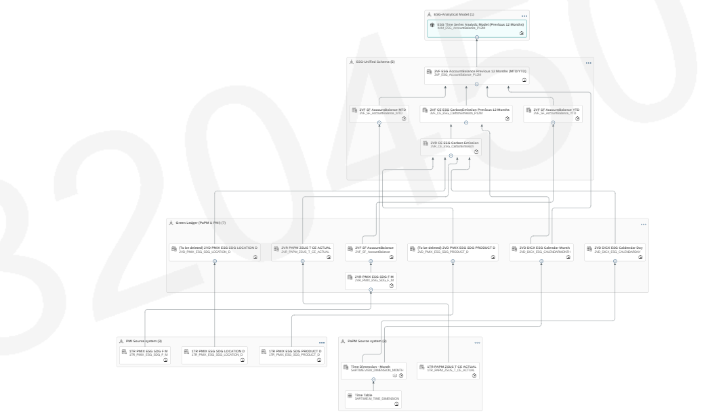

- SF Performance Analytic Model w/o Pivot

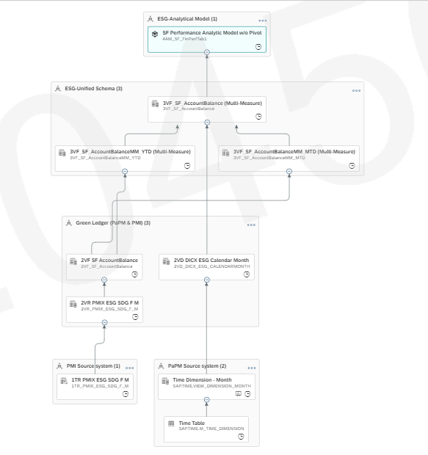

- CE Carbon Emission Analytic Model w/o Pivot

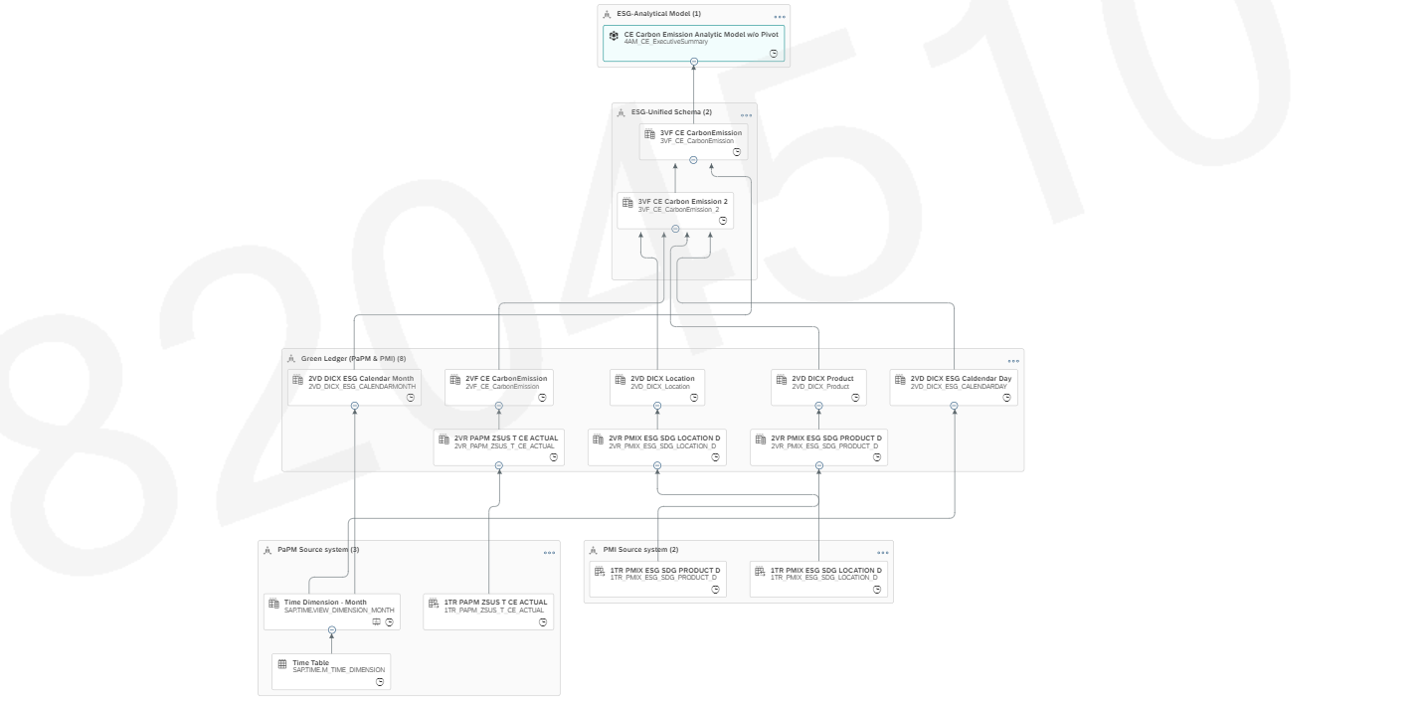

Consumption Model
N/A

Perspectives
N/A

Fact Model
Fact models can be used in multiple Consumption Models reducing the need to recreate calculations and select attributes.

Input Parameters
N/A

Design Consideration
The Reporting Layer should be separated for business consumption, respecting authorisations, but avoiding the need to recreate the same dimensions and facts in different spaces.

Row level security
Row level security requires a table of User IDs to field secure (e.g., Location , Segment , Product etc) to be uploaded or maintained.
SAP Datasphere implements row level security with Data access Controls. Creating a Data Access Control on a table in the Administration space populated with User ID and the field to be secured should be considered during Design workshops.
The application of Data Access control is done in the Propagation Reporting Layer (ESG space) to restrict data for each user.
Data Access Control User Table is imported as Remote Table and then it is shared with the propagation Layer (ESG Space)
DAC User View created in propagation layer and DAC for ESG reports is created in the same space. ESG Reports DAC enabled in the Fact Views (Fin performance , Executive Summary) then the data will be restricted in DSP model and SAC stories based on entries in the user table
DAC Flow Diagram:
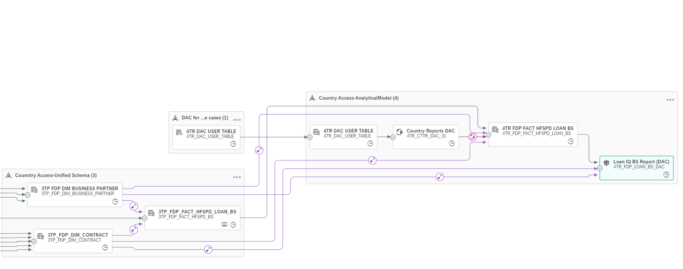

Authorisation scenarios
N/A

Naming Standards - TBC
Technical names of objects are unique in a space. i.e., The same technical name can be used in multiple spaces.
The SAP Datasphere naming conventions followed are as per Blog
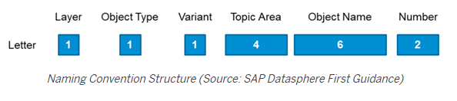

Letter | Length | Description | Examples
Layer | 1 | A common Modelling approach is to use stacked models with different layers.  Layers are logical groups of different entities (e.g., tables, views, data access controls, etc.). | 1 = Inbound Layer  2 = Harmonisation Layer  3 = Propagation Layer  4 = Reporting Layer | 1
Object Type | 1 | It is useful to recognize already in the name of the object to which layer it is assigned. This also applies to the object type and different variants of tables or views. | T = Table  V = View | T
Variant | 1 | Either numbers or letters are suitable for this purpose | “A” = Analytical  “R” = Reporting  “H” = Harmonization  “P” = Propagation | R
Topic Area | 4 | In some cases, several Topic Areas are stored in one Space (e.g., cost center as one area in a financial Space). Here it can be helpful to include the topic area in the name. | "FIN" = Finance  “CAP” = Capital  “LIQ” = Liquidity | FIN
Object Name | 6 | The object name should describe the object itself. If necessary, more than six letters or characters can be chosen for the object name. |  | KPI001
Number | 2 | Finally, it may be useful to append a two-digit number. This is especially relevant when multiple versions of similar artifacts are used for different purposes. |  | 01
Example |  |  |  | 1TR_FIN_KPI001_01

Administration
An Administration space is created to hold the views related to the administration of SAP Datasphere which may include internal SAP Datasphere tables to provide metrics on:
- Performance
- Data loads
- Table sizes
The administration space has elevated permissions.
How will administrators manage data access control / role level security and monitor system usage…

SAP Datasphere Roles
Roles provide permission to activities across the whole SAP Datasphere tenant. Roles do not provide access to data and objects in specific spaces, which is dealt with in the following section.
The following roles will be created (initially a copy of SAP delivered roles and adjusted for SCB requirements).
- Administration Role – to create users and spaces and has full privileges across the whole SAP Datasphere tenant.
- Modeller Role – to create and edit objects in the Data and Business Builder spaces to which they are a member.
- Integration Role – to create and edit connections and database users in spaces to which they are a member
- Viewer Role – to view objects of which they are a member.
- Consumer Role – to leverage SAP Analytics Cloud capabilities to consume data from spaces of which they are a member.
This section above needs to be updated for recently introduced scoped roles.

Monitoring
- System Monitor – Explain Dashboard and Logs
- Data Integration Monitor
- Remote Table Monitor
- View Persistency
- Data Flow Monitor
- Remote Query Monitor
- Task Chain Monitor

TECHNICAL SPECIFICATION – TASK CHAINS
N/A

Task Definition
Task Name | < Task Name >

- PLATFORM & INFRASTRUCTURE

SAP ANALYTICS CLOUD CONNECTIVITY
Datasphere live connection is used to connect Datasphere with SAP Analytics Cloud.

FOLDER STRUCTURE
Reports are available in ESG Dashboard folder inside public Folder.

USER SECURITY

Roles

Content viewer

Super User

BI Admin

Teams

Users

SAP DATASPHERE CONNECTIONS

SAP HANA Cloud Live connection

SINGLE SIGN ON
N/A

PERFORMANCE
N/A

Scalability and Projected Growth
N/A

Capacity / Load / Throughput
N/A

CLIENT
N/A

Network
N/A

Archiving & Retrieval
N/A

Disaster Recovery
N/A

Monitoring and Logging
N/A

- APPENDIX C – DEPLOYMENT STEPS
N/A

Pre-requisites
Create file-based transports using export and import from a file.

Deployment Steps

No | Step | Resp. | Date | Status | Comments
1 | < e.g., Deploy transport xxxxxx to the target system > | < Initials>

Post-Deployment Verification Steps

No | Step | Resp. | Date | Status | Comments
1

Rollback Steps

No | Step | Resp. | Date | Status | Comments
1

